**DIGITAL MARKETING ASSIGNMENT**

**QUESTIONS**

1.Create a blog or website using Blogspot and WordPress. Customize the theme design and post new article with 500 words.

SCREENSHOT:

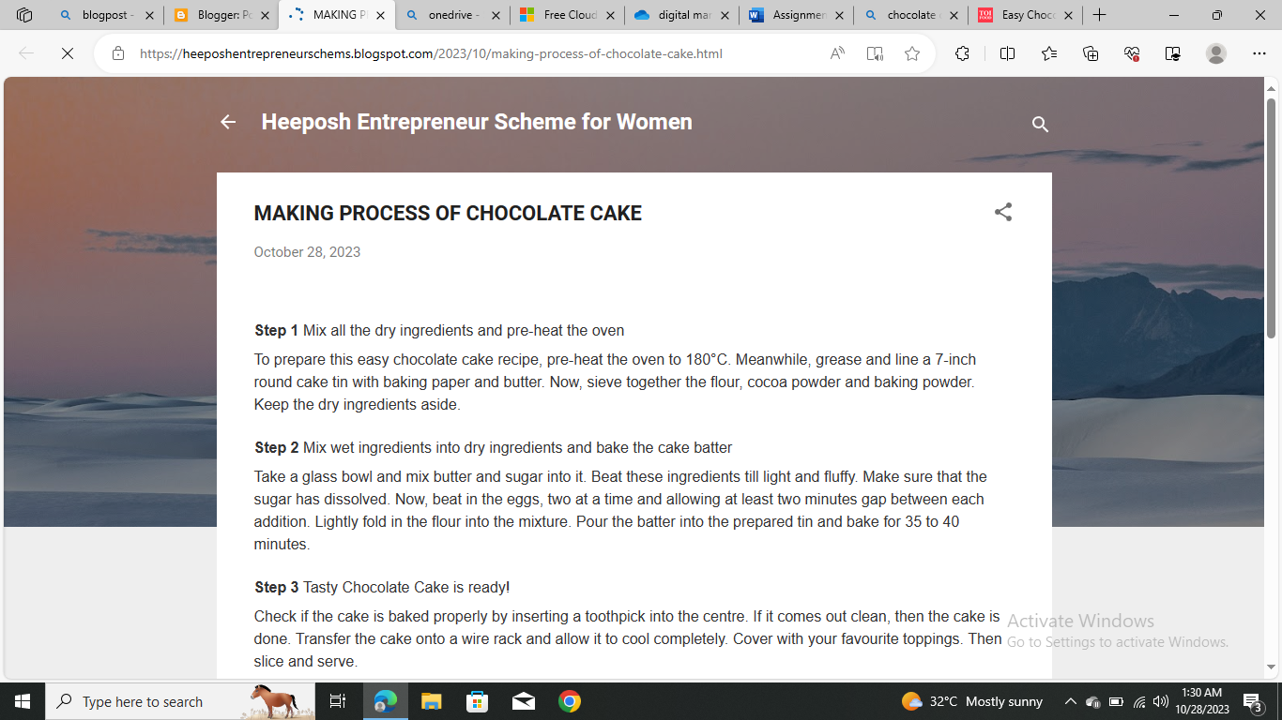

LINK:

https://heeposhentrepreneurschems.blogspot.com/2023/10/making-process-of-chocolate-cake.html

2. Create a New Facebook Business Page and post one social media poster for your brand.

SCREENSHOT:

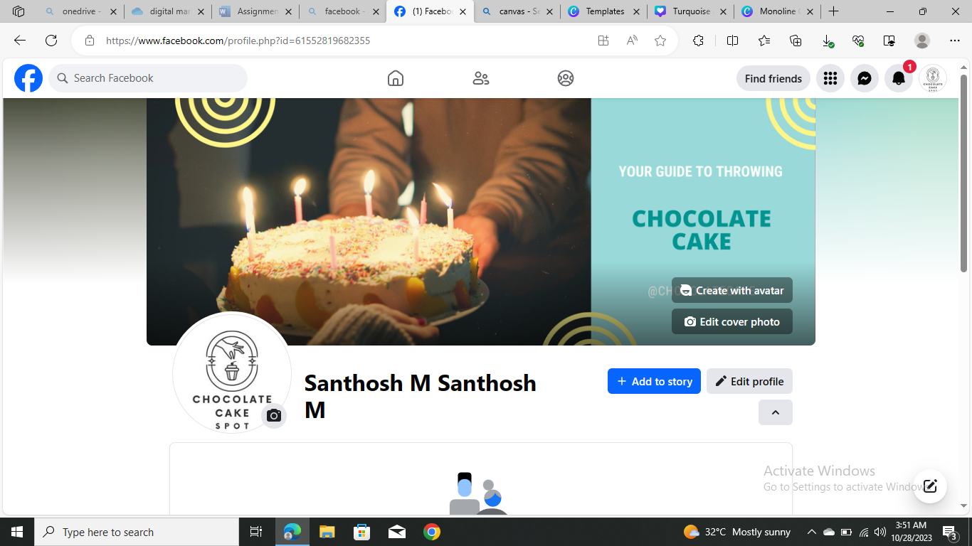

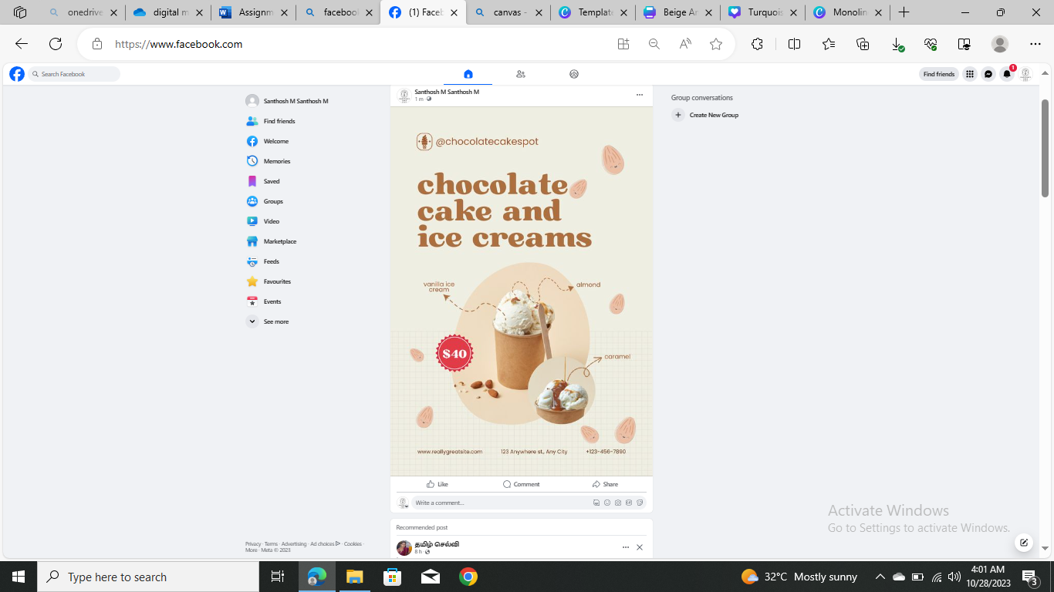

PROFILE LINK:

[(1) Facebook](https://www.facebook.com/profile.php?id=61552819682355)

POSTER LINK:

[(1) Facebook](https://www.facebook.com/photo?fbid=122099087618093989&set=a.122099087654093989)

3. Create and design a social media advertisement poster using canva.

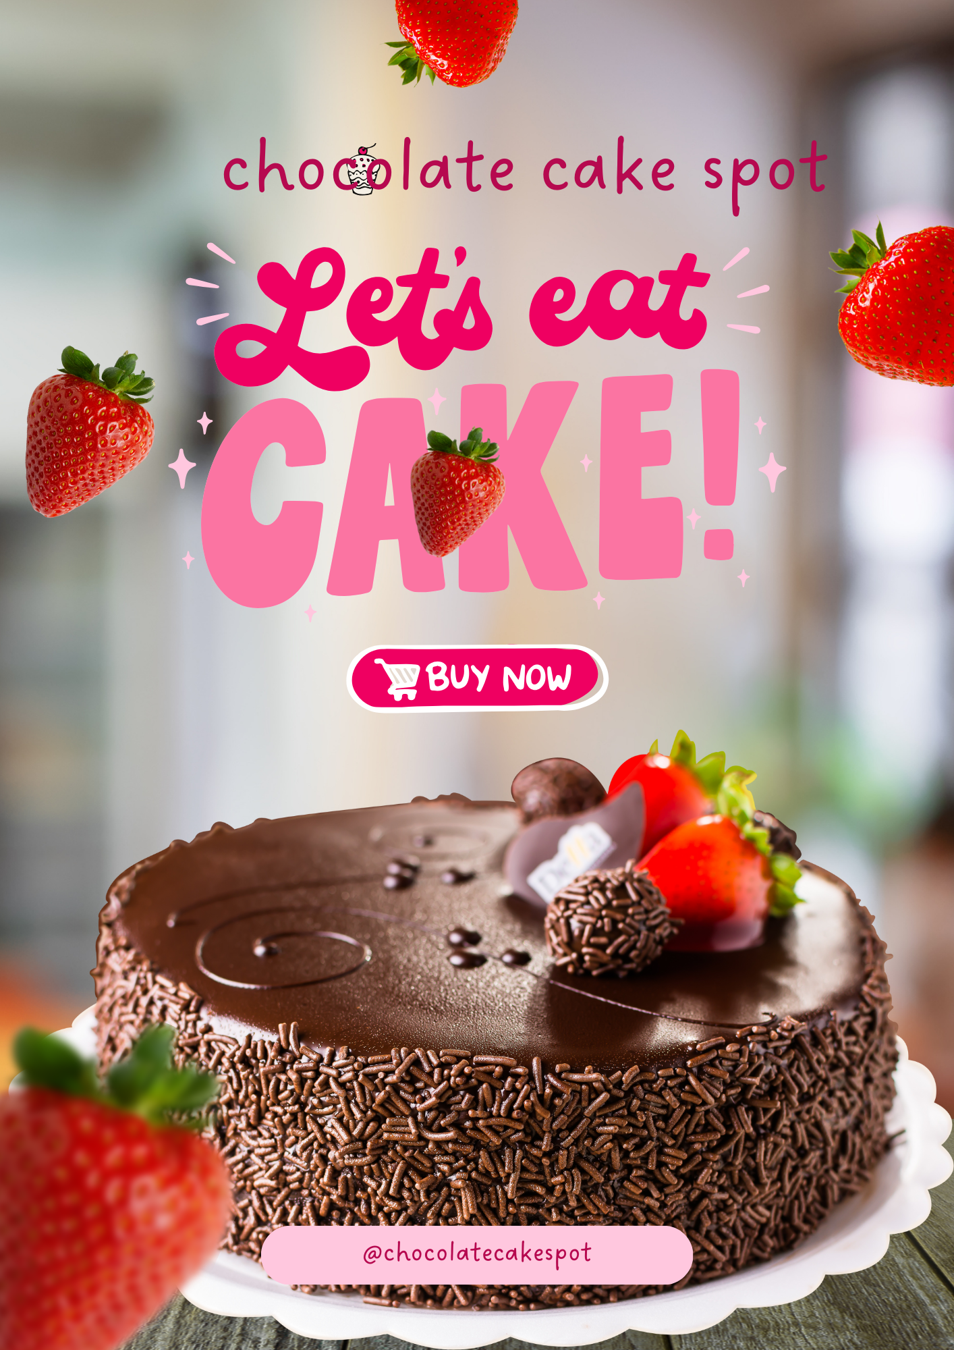

LINK:

https://www.canva.com/design/DAFyi9dfxT8/vmwJ1j6dz7Tlcd9XYWIslQ/view?utm_content=DAFyi9dfxT8&utm_campaign=share_your_design&utm_medium=link&utm_source=shareyourdesignpanel

4. Create email newsletter design using MailChimp or canva tool.

SCREENSHOT:

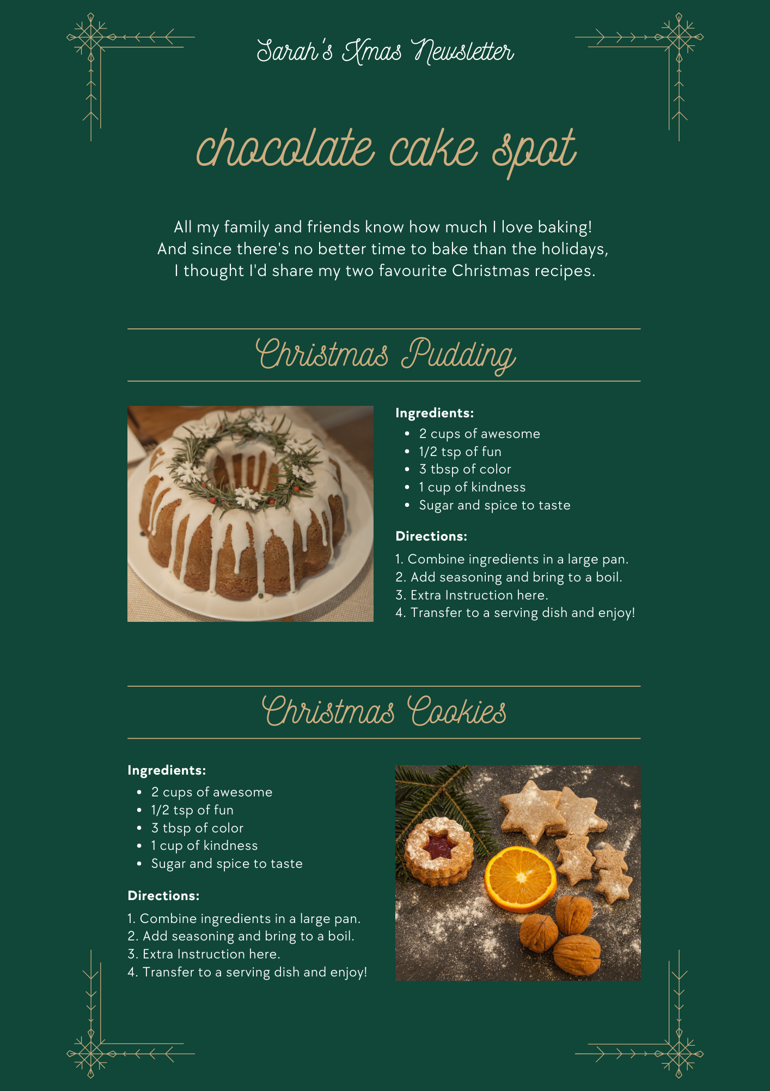

LINK:

https://www.canva.com/design/DAFyizlbN_w/lwYlmoOUOcCxgeKVlxaXzg/view?utm_content=DAFyizlbN_w&utm_campaign=share_your_design&utm_medium=link&utm_source=shareyourdesignpanel